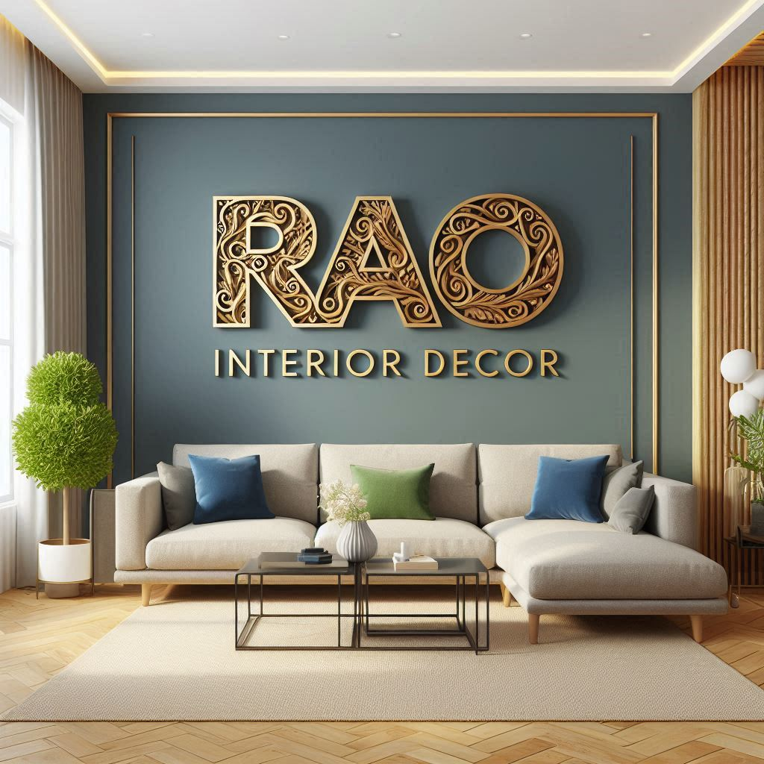

We take all kind of interior work

* Pop
* Painting
* Furniture
* Plumbing
* Civil work
* Electric work

Rajvendra singh rao ( civil eng )

+91 7977523959